**Project Documentation**

# 1. Introduction

Project Title: Rythmic Tunes

Team ID:

Team Leader: ZARINA FIRTHOUS S-24cszarinafirthous107@gmail.com

Team Members:

- SUSMITHA [S-24cssusmitha102@gmail.com](mailto:S-24cssusmitha102@gmail.com)

- PRIYADARSHINI [P-24cspriyadarshini072@gmail.com](mailto:P-24cspriyadarshini072@gmail.com)

- PRIYA [B-24cspriya71@gmail.com](mailto:B-24cspriya71@gmail.com)

# 2.Project Overview

Purpose: Rythmic Tunes is a music-based platform that offers personalized playlists, dance rhythm

guidance, and a creative space for music lovers.

Features:

- Playlist creation and recommendations

- Rhythm-based dance tutorials

- User community interaction

- Admin panel for content management

# 3. Architecture

Frontend: React.js, Tailwind CSS

Backend: Node.js, Express.js

Database: MongoDB

# 4. Setup Instructions

Prerequisites: Node.js, MongoDB, Git, VS Code

Steps:

- Clone repo →git clone

- Install client →cd client && npm install

- Install server →cd server && npm install

- Run →npm start (both client & server)

Installation steps:

1. Install audio/video editing software.

2. Import rhythmic tune and voice-over files.

3. Record or upload final voice-over.

4. Sync voice-over with tune.

5. Adjust sound effects and volume.

6. Preview and test playback.

7. Export final project file.

8. Install on presentation device and test.

5.Folder Structure

# 

| Rhythmic_Tune_Project/

|

├── Audio/

│ ├── Rhythmic_Tune.wav

│ ├── VoiceOver_Final.wav

│ └── SoundEffects/

│ ├── Video/

│ ├── Project_Video.mp4

│ └── Clips/

│ ├── Scripts/

│ ├── VoiceOver_Script.docx

│ └── Notes.txt

│

├── Project_Files/

│ ├── Editing_Project_File.aep (Adobe After Effects, if used)

│ ├── Editing_Project_File.prproj (Premiere Pro, if used)

│ └── Backup/

│

├── Export/

│ ├── Final_Output.mp4

│ └── Final_Output.wav

│

├── Installation_Guide/

│ └── Installation_Steps.docx

│

└── Reports/

├── Project_Report.docx

└── Presentation_Slides.pptx

5. Running the Application

Frontend →http://localhost:3000

Backend →http://localhost:5000

# 6.Screenshots or Demo

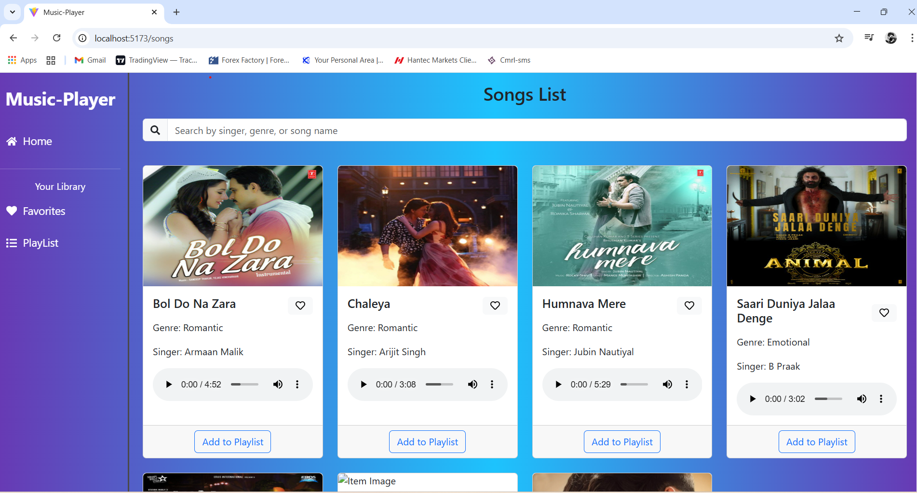

7. Future Enhancements

- AI-based music recommendations

- Mobile app version

- Offline playlist support